The Fedora-based NSDL Data Repository (NDR)
Prepared for the NSDL Pathways Meeting August 18-19
Dean B. Krafft

Background
For the past several years, the central repository for the NSDL project has been the Metadata Repository (MR). This is an Oracle database that aggregates metadata records from over 100 collection providers. There are over 800,000 metadata records in the repository. Each identifies a digital science resource, provides Dublin Core metadata about the resource, and generally includes a URL to the resource on the web.
Information is ingested into the MR by harvesting collections using the Open Archives Initiative Protocol for Metadata Harvesting (OAI-PMH). In addition, collection records and recommended resources are managed by the CRS (Collection Registration System).
The MR functions as a union catalog for all the science resources in the NSDL library. The MR serves to both aggregate all the catalog records from a number of providers, and to normalize them, creating a single source for known good records. The MR is used directly by both the NSDL search service, to create the search indexes used at nsdl.org, and the archive service, which archives date-stamped snapshots of publicly available resource content.
As we gained experience with NSDL providers and users, and as we mapped out new potential services for the NSDL, it became apparent that there were a number of new requirements that could not be easily addressed by the current MR. These included:
- The need to present a resource-centric view of the NSDL. Since the MR was just an aggregation of external metadata records, it was possible to have a number of different records that described the same resource. This resulted in independent search hits and did not support presenting a single view of everything that was known about the resource.
- The need to represent content, not just metadata, directly in the NSDL repository. This might include annotations, reviews, or information on structuring a set of resources in a lesson plan.
- The need to represent explicit relationships among resources in the repository. While the MR allowed for single level collection/item relationships, it did not support more complex relationships, such as “resource A is a review of resource B” or “resource C is a lesson plan that makes use of resources D, E, and F”
- The MR contained no information about who or what organization provided a particular piece of information about a resource, other than the notion that the resource was part of a specific collection.
To address these limitations and create an infrastructure that could grow far beyond the “union catalog” list of science resources, we decided to build a new NSDL Data Repository, which would both subsume all the functions of the existing MR and provide an infrastructure that could support the growth of resources, providers and services for the foreseeable future. After reviewing the available options, we chose to use the Fedora digital object repository middleware to implement the NDR.

Fedora – Flexible, Extensible, Digital Object Repository Architecture
The Fedora Project is an ongoing research and development effort to provide the framework for creation, management, and preservation of existing and evolving forms of digital content. The roots of the project lie in DARPA-funded research in the early 1990’s that defined the notion of a digital object and implemented Dienst, a networked digital library architecture with protocol-based dissemination of digital objects in multiple formats. Further development of Fedora was carried out as part of several Cornell research projects in the late 1990’s.
The transition of Fedora from a research prototype to production repository software began when the University of Virginia Library, seeking a solution for managing increasingly complex digital content, experimented with the Fedora architecture in 2000. The experimentation proved successful, providing the basis for subsequent funding from the Andrew W. Mellon Foundation to Cornell and Virginia to jointly develop Fedora and make it available as open source software to libraries, museums, archives, and content managers, facing increasing variety and complexity in the digital content that they manage. Mellon-funded development continues through 2007.
Fedora is implemented as a set of web services that provide full programmatic management of digital objects as well as search and access to multiple representations of objects. Fedora objects contain content streams (text, image, binary, etc.), which can be either internal to the repository or else redirects to content anywhere on the web. Access to Fedora objects is through disseminators, which can reformat the content (e.g. present an image as PNG, JPEG, or TIFF) or combine multiple content streams into a single output. This creates an extraordinarily flexible architecture for representing and manipulating digital objects.
All Fedora APIs are described using the Web Service Description Language (WSDL). As such, Fedora is particularly well-suited to exist in a broader web service framework and act as the foundation layer for a variety of multi-tiered systems, service-oriented architectures, and end-user applications. This distinguishes Fedora from other complex object systems that are turn-key, vertical applications for storing and manipulating complex objects through a fixed user interface (e.g., DSpace, arXiv, ePrints, and Greenstone).
The latest version of Fedora integrates the existing advanced content management system with semantic web technology. It supports the representation of rich information networks, where the nodes are complex digital objects combining data and metadata with web services and the edges are ontology-based relationships among these digital objects. These relationships are stored in an RDF triple-store (Kowari), which supports arbitrary queries over the relationships.

Fedora and the NSDL Data Repository
The Fedora middleware provides the flexible structure of digital objects and relationships that allows us to support all the new requirements that could not be handled by the old MR. We can explicitly represent resources as digital objects, and associate with them multiple metadata records from different sources. We can explicitly represent the organizations and individuals that provide metadata or select resources, and relate them to the appropriate metadata and resources. Since Fedora is fundamentally a content repository, it can represent content such as annotations or reviews. Finally, the RDF-based flexible relationship structure in Fedora allows us to represent arbitrary relationships among resources, for example relating all those that match a particular educational standard, or structuring the resources that are assembled into a lesson plan.
The diagram below shows an extremely simple instantiation of the NDR, with four collections, three metadata providers, three agents, three resources, and four metadata records.
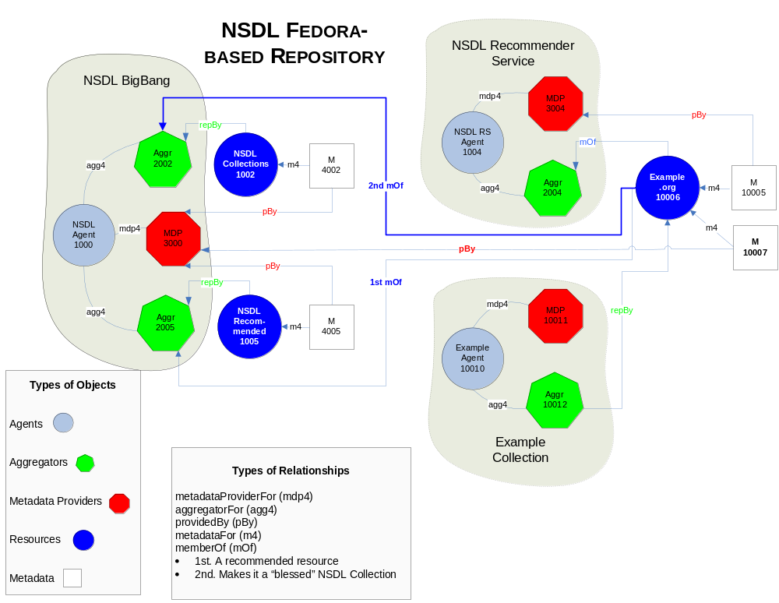

Our goal in the NSDL is not only to provide a digital library allowing search and access to distributed resources, but to augment NSDL resources with context that defines their usability and reusability in different learning and teaching environments. By “context”, we mean information such as the provenance of the resources, the manner in which resources have been used, comments by users that annotate and explain primary resources, and linkages between the resources and relevant state educational standards.
Using the content management and semantic web tools in Fedora we have implemented the NDR as information network overlay on top of the web. Using the web services architecture, the Fedora digital objects and their disseminations become a lens or filter into the underlying web content. High-quality educational resources are “filtered out” of the mass of the web and made available through the NDR. The relationship architecture then allows us to augment these resources with critically important educational context.

Current Status
Our initial implementation of the NDR is intended as a functional replacement for the current MR, supporting existing collection ingest, search, archive, and recommendation services. We anticipate having a demonstration version of the new repository, running from resource ingest through exposing search results on a test version of the nsdl.org website, available in mid-August. A full production version, replacing the current MR, should be in place about a month later.
The NDR is currently accessed through an internal API, which supports finding, creating and manipulating NDR digital objects. Through the fall, we plan to work with the Pathways and other partners to develop a public API for the NDR. This will allow Pathways, collections, and service providers to directly create and access resources, metadata, and relationships in the NDR, without having to work through the limited OAI-PMH ingest model supported by the initial NDR implementation.
Through the fall and winter, we will be making available a variety of services on top of the NDR. These include resource-centric search results, integration of the SDSC archive service into the NDR Fedora-based architecture, and an NDR-integrated weblog system to support resource recommendation, annotation, augmented metadata, and a number of other capabilities.

